**(EEL2020)** **DIGITAL DESIGN LAB1 REPORT**

KARTIK CHOUDHARY B20CS025

**Work 1: Create a Half Adder. Write its test bench and Simulate**

*Program Code*

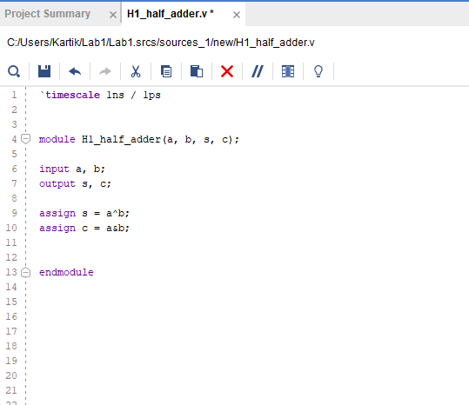

*Test bench*

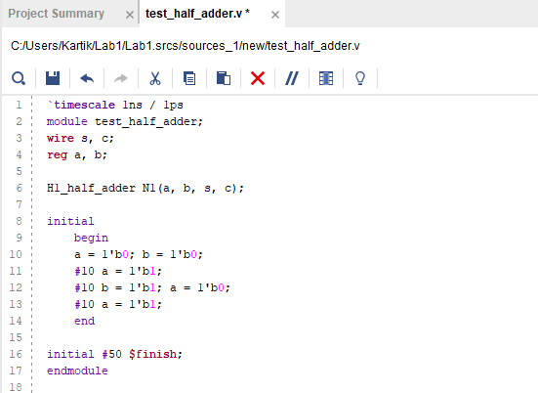

*Waveform*

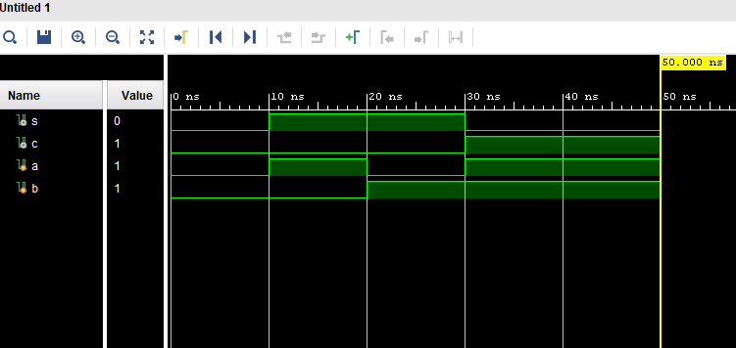

**Work 2: Use Half Adder to Create a Full Adder**

*Program code*

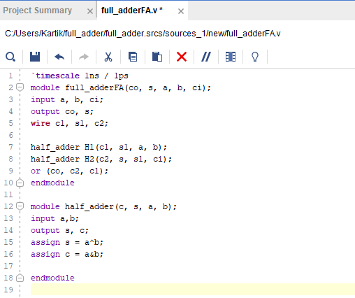

**Work 3: Use Full Adder to Create a Four Bit Adder. Write its test bench and simulate.**

*Test bench*

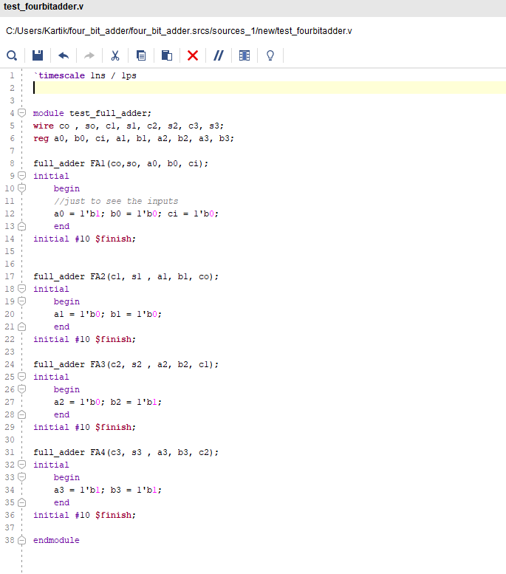

*Program code*

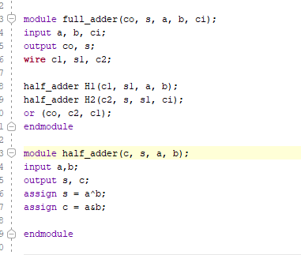

*Waveform*

Here we have selected two 4 bits inputs for the addition 1001 and 1100 which is the addition of 9 and 12 (decimal), hence should give output 10101 i.e., 21(in decimal)

